Traffic Simulating System
Software Architecture Document

Version 2.0

Revision History
Date | Version | Description | Author
24/Nov/2008 | 1.0 | Draft of SAD | Mohan Yang
05/Jan/2009 | 2.0 | Final Version | Mohan Yang

Table of Contents
1. Introduction 4
1.1 Purpose 4
1.2 Scope 4
1.3 Definitions, Acronyms, and Abbreviations 4
1.4 References 4
2. Architectural Representation 4
3. Architectural Goals and Constraints 4
4. Use-Case View 5
4.1 Architecturally-Significant Use Cases 5
5. Logical View 5
5.1 Overview 5
5.2 Architecturally Significant Design Packages 6

Software Architecture Document

Introduction

Purpose
This document provides a comprehensive architectural overview of the system, using a number of different architectural views to depict different aspects of the system. It is intended to capture and convey the significant architectural decisions which have been made on the system.

Scope
This Software Architecture Document provides an architectural overview of the Traffic Simulating System. The Traffic Simulating System is being developed by SJTU 06ACM Honored working group.

Definitions, Acronyms, and Abbreviations
See the Glossary [2].

References
Applicable references are:
- Vision, V2.0, 04/Jan/2009, SJTU 06ACM Honored Class.
- Glossary, V1.0, 05/OCT/2008, SJTU 06ACM Honored Class.
- Use-Case Specification: Load map, V2.0, 05/Jan/2009, SJTU 06ACM Honored Class.
- Use-Case Specification: View Statistic, V1.0, 05/OCT/2008, SJTU 06ACM Honored Class.
- Use-Case Specification: Car Simulating, V3.0, 04/Jan/2009, SJTU 06ACM Honored Class.
- Use-Case Specification: Add vehicle, V1.0, 05/OCT/2008, SJTU 06ACM Honored Class.
- Software Requirements Specification, V2.0, 08/Jan/2009, SJTU 06ACM Honored Class.
- Supplementary Specification, V1.1, 01/Jan/2009, SJTU 06ACM Honored Class.

Architectural Representation
This document presents the architecture as a series of views; use case view, logical view, process view and deployment view. There is no separate implementation view described in this document. These are views on an underlying Unified Modeling Language (UML) model developed using PowerDesigner.

Architectural Goals and Constraints
There are some key requirements and system constraints that have a significant bearing on the architecture. They are:
- The existing external road information system must be interfaced with to support loading map information and creating map from real world.
- The existing external vehicle information system must also be interfaced with to support loading vehicle information and creating specified vehicle.
- All performance and loading requirements, as stipulated in the Vision Document [1] and the Supplementary Specification [8], must be taken into consideration as the architecture is being developed.

Use-Case View

Architecturally-Significant Use Cases
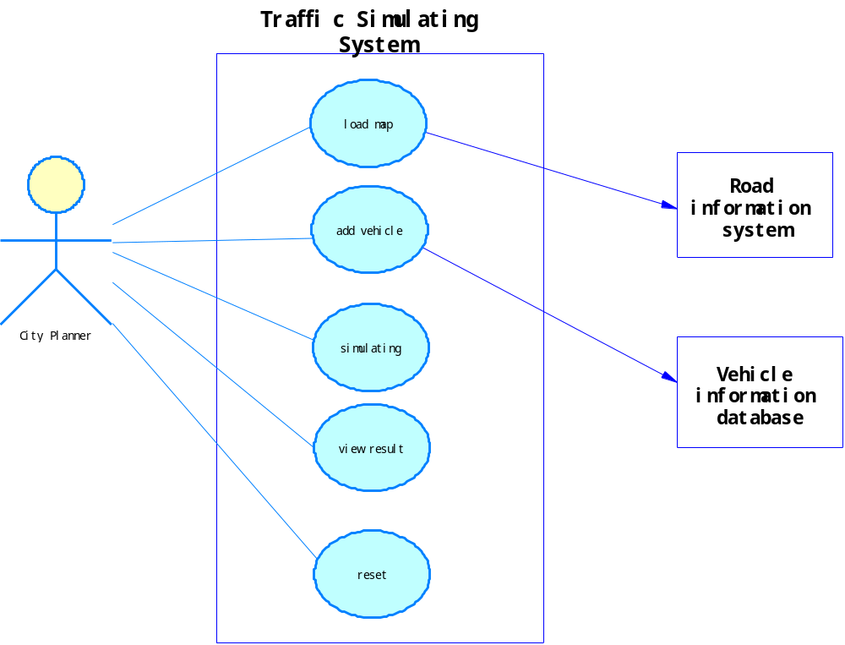
About the detail of each use-case see the reference [3] – [6].

Logical View

Overview
We use three layer structures which are the UI layer, the domain layer and the entity & data layer.
- The UI layer handles with output task such as console output or graphic user interface view.
- The domain layer handles with simulating task which is the kernel and the main part of the system.
- The entity & data layer handles with real data definition and convert the data from external system into the internal format needed.

Architecturally Significant Design Packages
